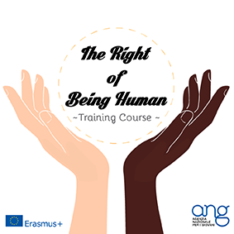

TRAINING COURSE
ERASMUS+ Mobility of Youth Workers
“THE RIGHT OF BEING HUMAN”
February 27th 2015 / March 8th 2015
Nardò (Lecce) - ITALY

APPLICATION FORM

First Name and Surname (as in your passport):

Gender:

Date of birth (day/month/year):

Citizenship:

Personal Address (street, postal code, town and Country):

E-mail:

Contact phone number:

Sending Organisation:

Special wishes and dietary requirements:

Any serious illnesses, disabilities, allergies:

Language skills (What languages do you speak? Put: G for good, F for fair, S for slight):

Give details of your voluntary/community work experience:

Please, describe your experience in the field of human rights:

Please, describe your experience in tools of promotion and communication/ photo and video-making/ creativity:

What is your main motivation to take part in this Training Course?

What do you expect to gain from your participation?

Any other information/comments?

